User Guide

|  |  |  |
| --- | --- | --- |
| Supervisor | Sir Zaman | |
| Batch | 2202e | |
| Group | Maru Dry-Fruit | |
| Serial No. | Enrollment  Number | Student  Name |
| 1 | 1364329 | Muhammad Ameen |
| 2 | 1365962 | Muhammad Mustafa |
| 3 | 1366037 | Muhammad Anus |
| 4 | 1366017 | Muhammad Nauman |

|  |
| --- |
| USER GUIDE |

“Maru-Dryfruits” This website is based on dry fruits. If you want to buy the products, or you want any details regarding any dry fruit , so this is the write website to acknowledge any dry-fruit.

1 TOP LAYOUT:

Users can know about this website by clicking on the “Home” button.

Users can get in touch with the admin by the Contact Us page.

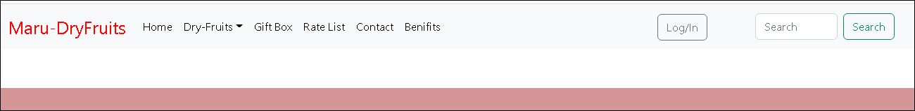

2 HOME PAGE:

**This page contains 2 main pages.**

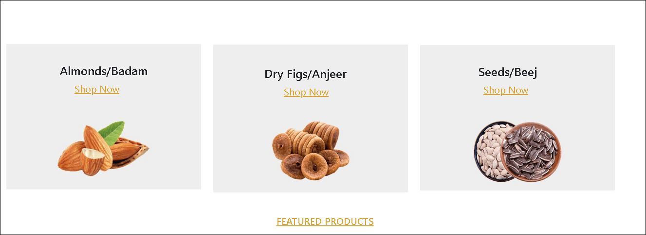

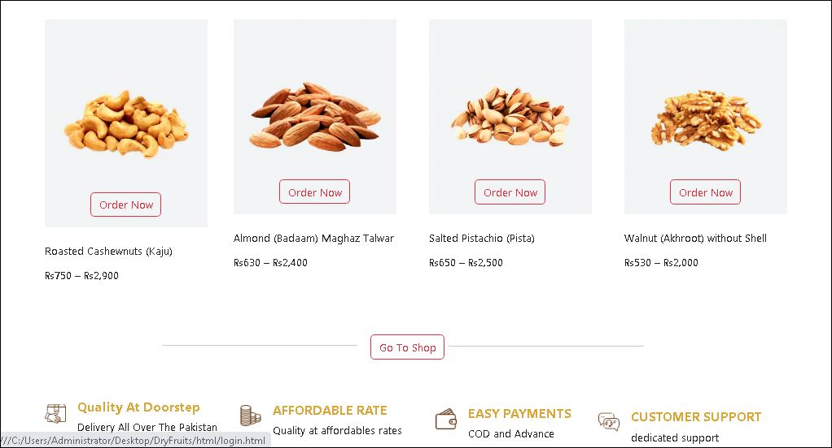

3. GIFT BOX:

**This is the GIFT BOX page.**

**This is the gift box page. In which we have the new item that having the new prices or discount items that user can buy easily with uss.**

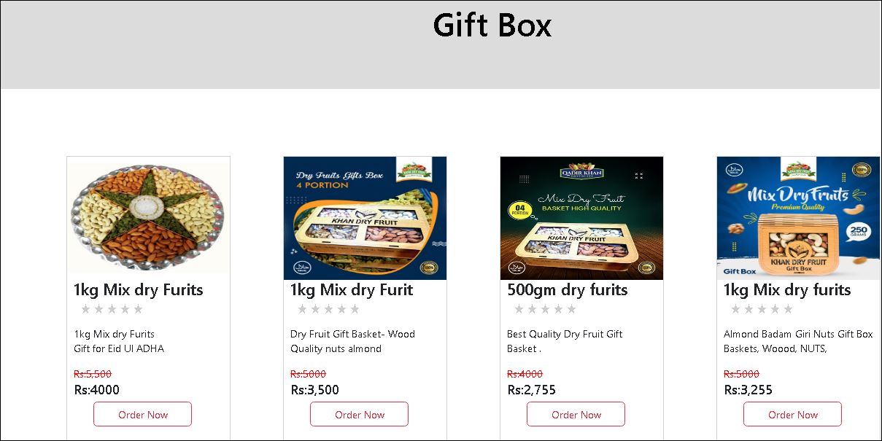

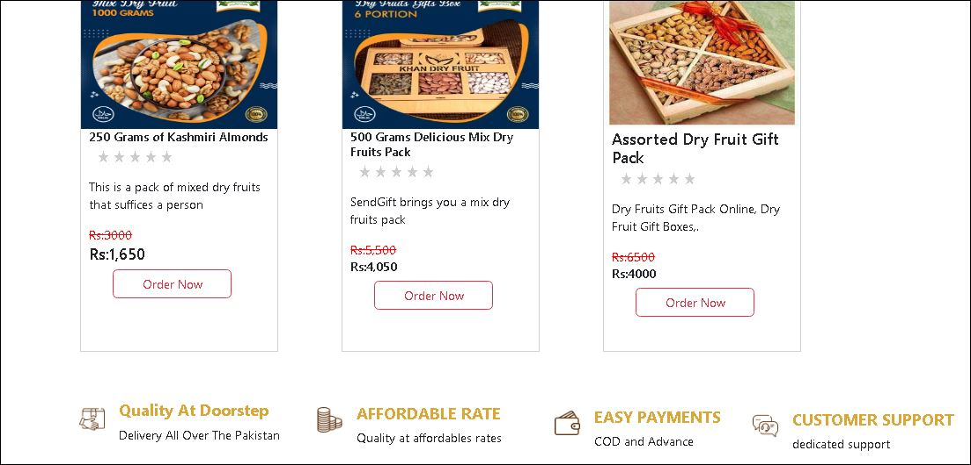

4. RATE LIST

**This is the RATE LIST page**

**This page includes all the prices of products which are given in our website, with all the prices (250gm, 500gm and 1kg) as per all the products that are given in our website.**

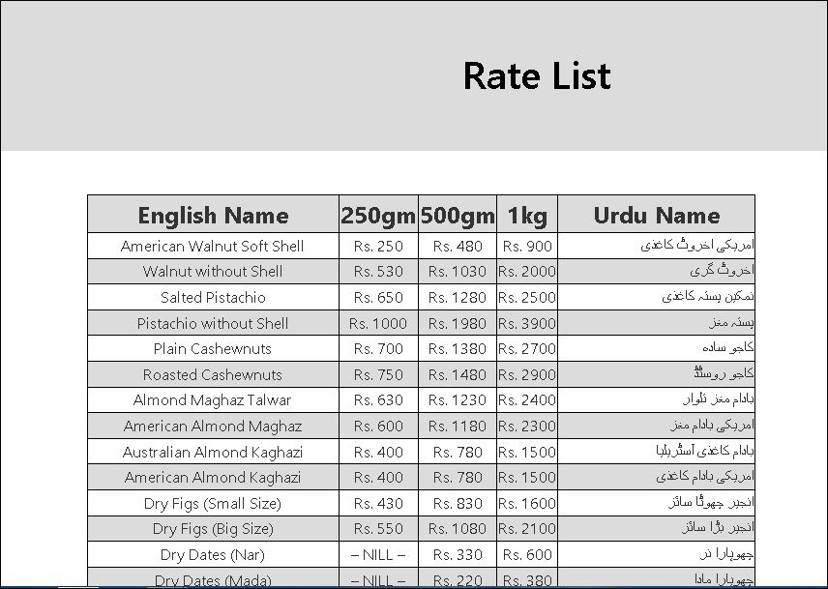

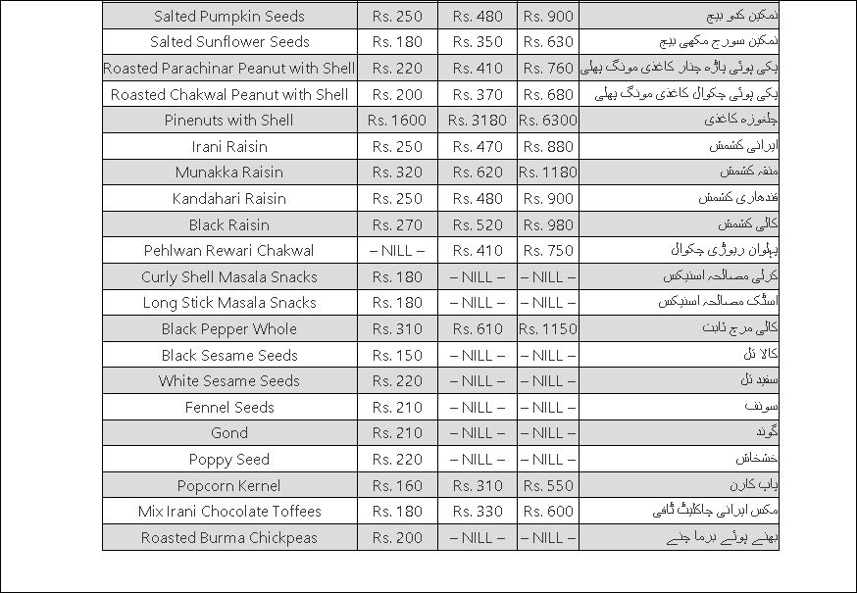

5. CONTACT US

**This is the CONTACT US page.**

**This page includes all the user guide for the message you want to know with the website that is in the contact us page. This also contact the WhatsApp number and our email id for the conversion. This page also includes the geo location app.**

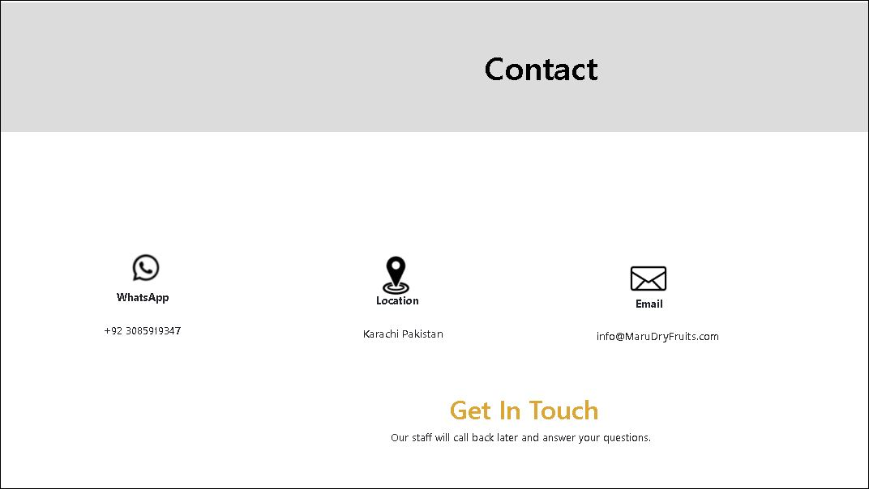

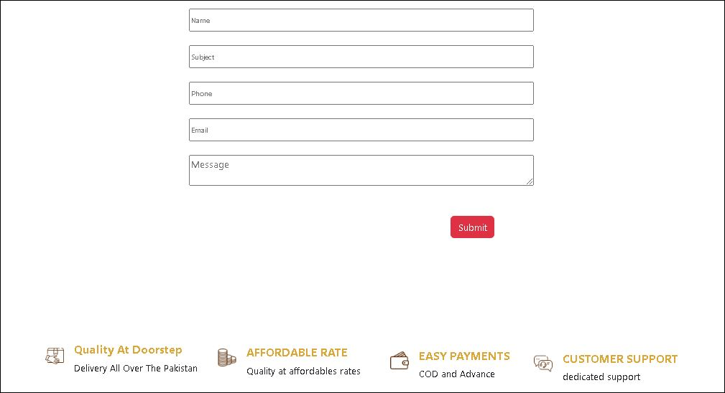

6. BENEFITS

**This is the BENEFITS page.**

**This page includes all the benefits of our dry fruits which are in this website with advantages and dis-advantages, and also include the side map in this page.**

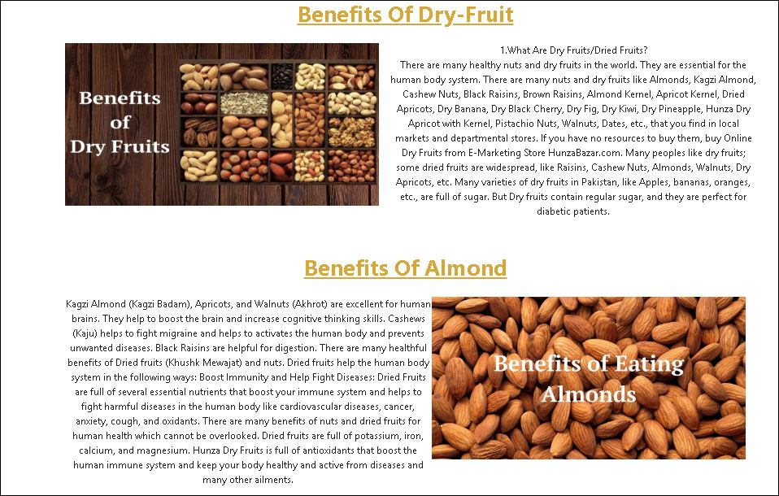

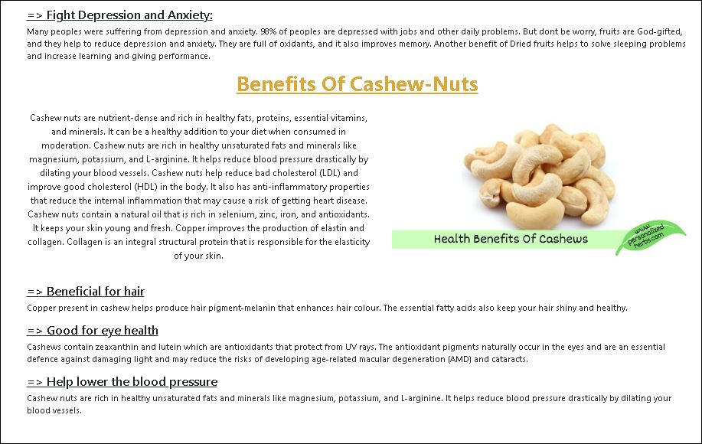

7. LOGIN PAGE

**This is the LOGIN page.**

**This page includes the login id you want to first register for website , so that you want to buy as the new products or you can also see our featured products.**

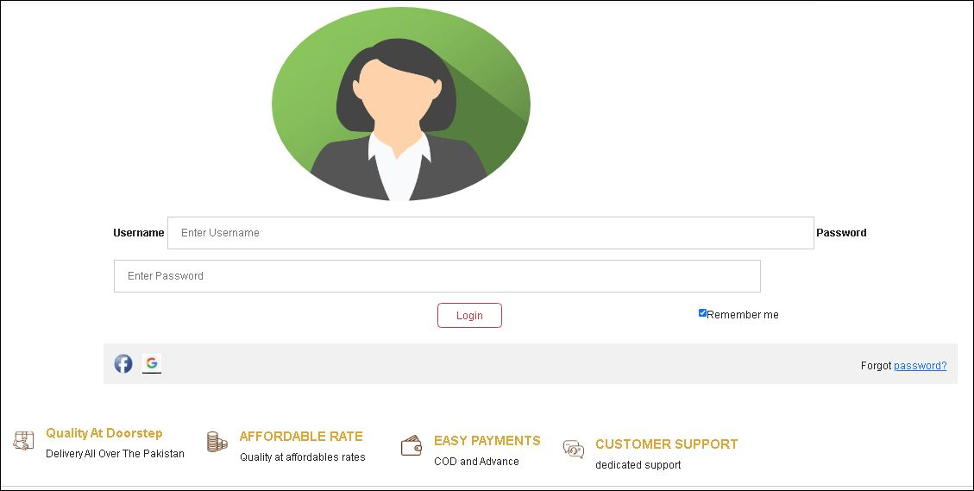

8. PRODUCTS

**This is the PRODUCT page.**

**This page includes our new products with the rating in the box so you want to buy us.**

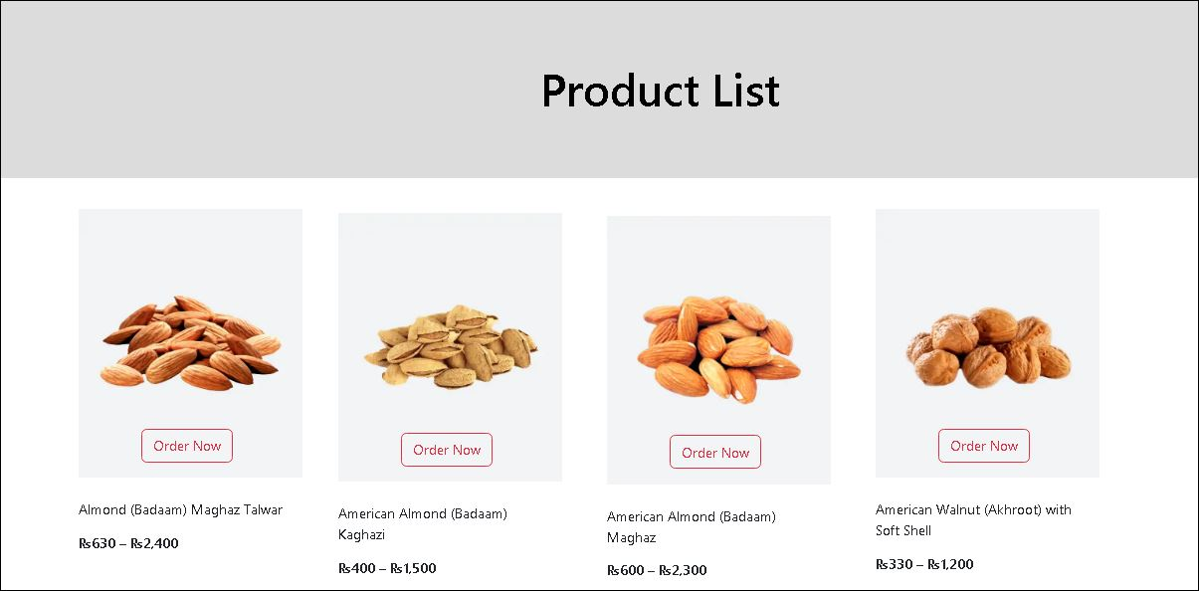

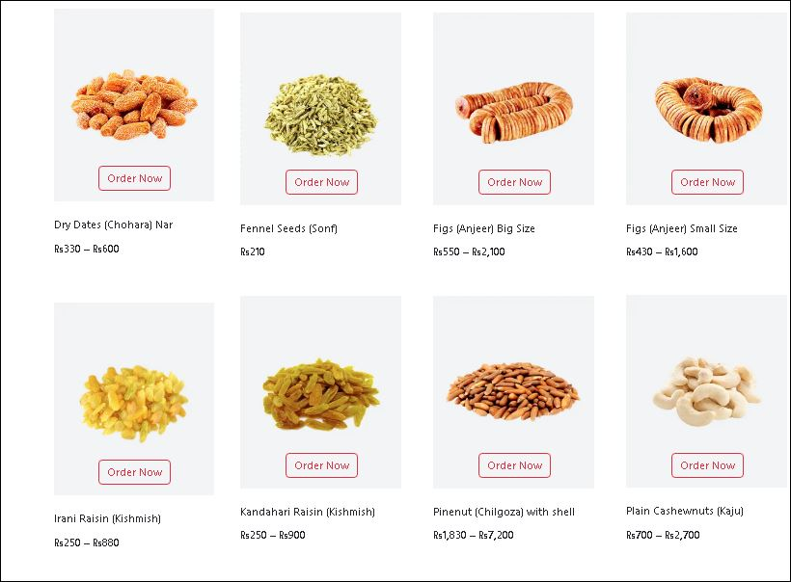

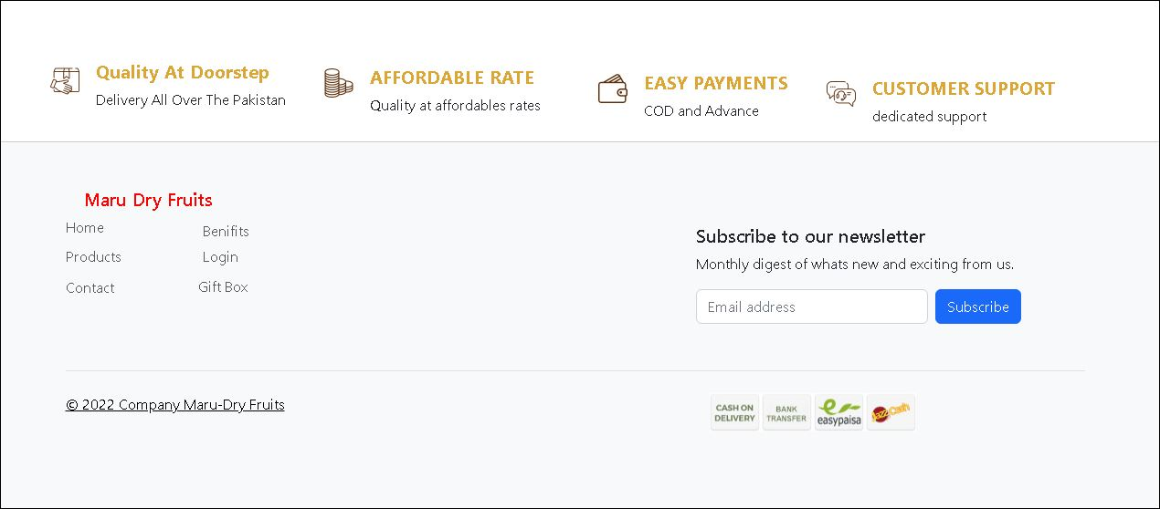

THANK YOU FOR READING

THIS DOCUMENTATION